Title: Interactive Aesthetic Growth Management
Work type: Interactive graphical computer program in Processing
Name: Elliot Chandler
Work Description: This project is to develop an ecosystem of simple virtual creatures that when together look pretty and do interesting actions. It should form an interaction with the person using it, who has some control to shape the way it evolves, sort of like a garden. The goal of this is to create a dialogue between the human and the computerized creatures, which will allow the experience of interacting with it to be much more interesting and engaging than if it were a static simulation like most demos. This could conceivably be considered as a game, although since the only “winning” state would be collaboratively (with the machine) growing an environment that the person working with it finds pretty, whether the traditional conception of a game applies to it is debatable. This gives the work some elements of performance art, as the role of the person interacting with the environment in shaping the progression of the art is in a sense a performance act for themselves, and the computer creatures would also be performing their roles in a sense. This allows the work to be both the software itself, as well as the individual experiences inherent to any use of the artwork. These ideas that I bring up were brought to my mind by the visiting artist Miwa Matreyek’s performance and lecture at the IMRC Center. According to Matreyek, the act of performance — the attentiveness and interaction between the audience and the artist — is a critical part of the artwork, rather than only the audiovisual content of the work. In this way, the artwork of the ecosystem of virtual creatures is in part the individual experiences any person interacting with it has, rather than just the software itself. I think this is valuable in providing a dynamic, immersive experience to the person using it, and allows me as the artist to both share in through shaping and remain partly ignorant of the actual artwork.
Work Intention: I like paintings that are rich, complex, and detailed. Especially Romantic-era paintings suit my taste in style. I had the idea to create a digital environment that a person could shape to create their own worlds, and I was curious whether, given enough variance and training of ideas by the person interacting with it, such a virtual ecosystem might create gorgeous visual scenes like that, or like are seen in reality. This would be an example of emergence, the idea that complex systems can come into being through the interactions and behaviors of a large number of simple entities that comprise the system. The interactive aspect of the work would allow a human guiding it to steer it in the directions they found aesthetically pleasing, which would perhaps help it create pretty results more easily than pursuing a purely practical goal automatically. It would also allow the human to have a more personalized experience with the artwork, so that it could be like a pet of them, that they could interact with and train and get to know. There should be a lot of similarity in interacting with this work to growing a garden or training a pet, if it is successful. I would like to have this be an experience that the person interacting with it would be able to have an influence over, bringing some of their own preferences into the way any given instance of the work lives, without being entirely reliant on the conscious thought and creativity of the person interacting with it (like, for example, a paint app would be). The work should be entertaining and relaxing to interact with, and should bring a feeling of contentment to the person using it. This is a feeling that I find some computer games invoke in me, but people I talk to do not understand so well, I hypothesize because the games generally contain fast-paced and chaotic elements; consequently, I would like to attempt to share that feeling with other people through this medium, although that is a secondary concern to me over the aesthetic aspect of it (granted, of which it may be a product).
Framing:
Work 1: “Evolved Virtual Creatures” — Karl Sims. https://www.youtube.com/watch?v=JBgG_VSP7f8
“Evolved Virtual Creatures” is a video showing a collection of creatures created through computerized simulation of evolution. I really like this video, and find the creatures shown in it very interesting. This focuses on creatures that exist in an environment with realistic physics, and their behavior influences what they are able to do within the environment using their own shapes and actions. My proposal does not include creatures that have such rich behaviors, lacking components that can move relative to each other, and they do not have the realistic physics of the environment to work in. That is to keep the project simpler. Creating more complex creatures like this, or plants, could be part of a more complex and ambitious entire nature simulation project.
Work 2: “Tamagotchi” https://en.wikipedia.org/wiki/Tamagotchi (mostly via description in class and at http://nmd430.sofianaudry.com/assignment-1/ ).
While I have not interacted with one myself, the idea of the tamagotchi inspired two aspects of this project. First, implementing the idea of a virtual pet, that interacts with and is influenced by the person interacting with it, as an environment seemed interesting and appealing to me, and that is the context where the garden-like/pet-like aspect of the work came to me from. Second, the use of states and conditions upon which transitions between the states are made influenced the way I developed the creature that breeds when it is given a lot of water. I expect to use that type of programming for many of the creatures I have not yet developed.
Work 3: “Algorithmic Music Composition” — Stefan J. https://www.youtube.com/watch?v=IHCfTvNDS_g
While this work does not have much similarity to my work in terms of the medium or implementation, this is a very good example of the works’ shared theme of how aesthetically appealing works can be created through human use of a technological system (regardless of how much of a role in providing creative input the human has), which is a core tenet of my goals in developing this project. Also, the use of a genetic algorithm in that work is a theme that I would like to use for one of the creatures in my own, having a creature that can be influenced by some factor, perhaps by an element of preference for some over other provided in some way by the person using the software, allowing the person to evolve the creature as its own little type of artwork.

Class relationship diagram

Roadmap
Final feature / task | Current status | Completion (%) | Time (h)
Final feature / task | Current status | Completion (%) | Planned | Spent
Creature template and management | done | 100 |  | ~1
Creatures that disperse themselves (template behavior for all) | If I stop trying to calculate physics for them, it should go faster. | 10 | 10 | ~5
Creature that changes shape |  | 0 | 1 | 0
Creature that changes color |  | 0 | 1 | 0
Creature that eats other creatures |  | 0 | 5 | 0
Creatures that breed when given lots of water | The dispersing creatures breed now, I just need to split it from them. | 50 | 1 | <1
Creature that can evolve using genetic combination and mutation | Sort of begun since library is available | 1 | 20 to 40 | 0
Creature that can take many shapes |  | 0 | 15 | 0
Creature that can have transparency (e.g. transparent gradient creatures) |  | 0 | 15 | 0
Creatures that change over time based on overall ecosystem: less active with less light, etc. | Need to define the ideas better | 0 | 10 | 0
Sun that goes around instead of bouncing (low priority and kind of hard) | Sun bounces up and down | 50 | 5 | ~1 or 2
Creatures that can combine with creatures near them (probably hard I bet, probably won’t try this) |  | 0 | [30] | 0
Total |  |  | 83? | 9?

Schedule: When things are complete
Finish dispersion creatures: 20 April
Finish simple breeds of creature (1h creatures marked in roadmap): 21 April
Finish the many shapes creature: 23 April
Finish transparency: 24 April
Finish the creature that eats: 25 April
Finish creature that evolves: 29 April
Add any more creatures if I have time: 30 April
Test and fix any bugs found: 1 May

  - April 25th 23rd: Prototype presentation
  - May 2nd: Final project presentation

Appendix
This is the version I had for the assignment:
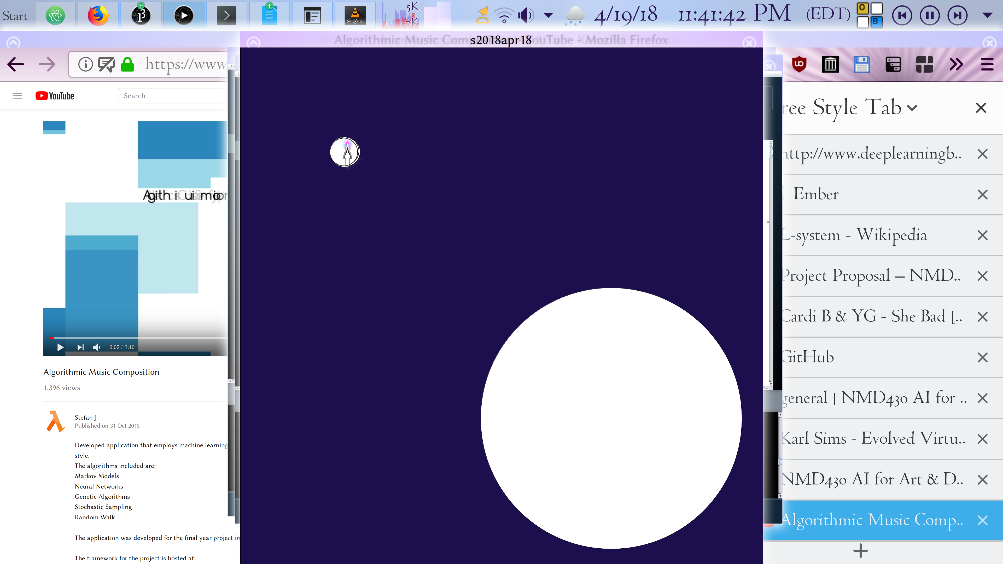
This is a sketch that I found managed to create aesthetically pleasing pictures and be very relaxing and fun, although it is rather simple:
